Title: Latitude and Longitude

What you will learn:
- Prepare a formal laboratory report using the template provided
- Cartesian coordinate system
- Latitude and Longitude
- Conversion from latitude/longitude to Cartesian Coordinates system

Resources: Read and study the following resources before doing the exercise.
- Definition of latitude and longitude from whatis.com http://whatis.techtarget.com/definition/latitude-and-longitude
- Conversion from latitude/longitude to Cartesian coordinate system https://cdn.citl.illinois.edu/courses/TSM352/TSM352_Labs/Module1_Lab01/M1_Lab01_Presentation01/index.htm

Laboratory Exercise

Map coordinates are often given in terms of latitude and longitude. However, these are angular measures and have to be converted to linear measures in order to calculate distances and areas.

Determine the area of the field shown below in both acres and hectares given the latitude and longitude of the corners.

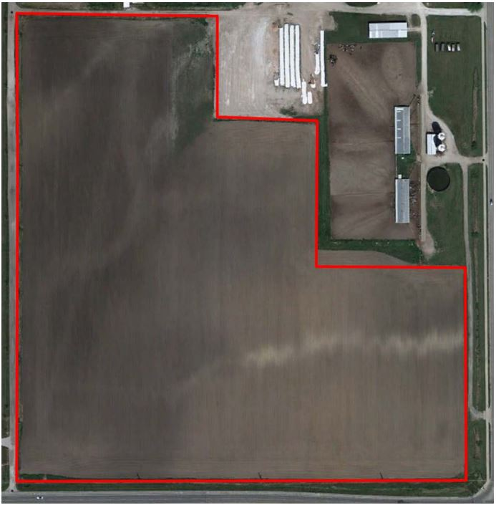
Figure 1. Aerial view of the field

Table 1. Coordinates of field boundaries
Corner | Longitude | Latitude
1 | -88.2236640 | 40.0868791
2 | -88.2215168 | 40.0868791
3 | -88.2215168 | 40.0864410
4 | -88.2204432 | 40.0864410
5 | -88.2204432 | 40.0856196
6 | -88.2191549 | 40.0856196
7 | -88.2191550 | 40.0837085
8 | -88.2236640 | 40.0837030
9 | -88.2236640 | 40.0856196
Local Origin | -88.2236640 | 40.0837030

Procedure:

- Open the Lat_Long_Converter.xlsx file and copy the local origin into the worksheet cells for the origin of Latitude and Longitude.
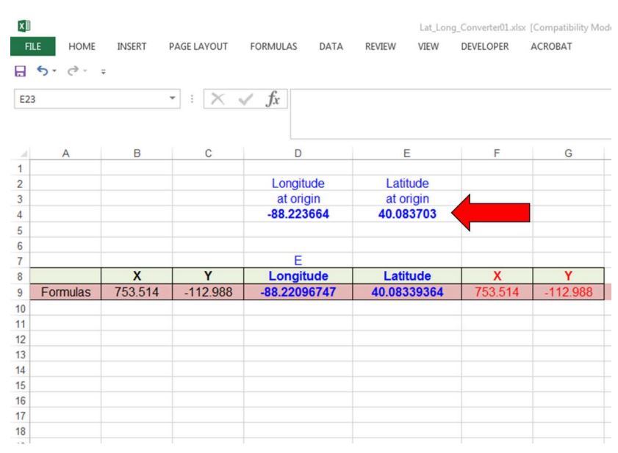
- Copy the latitude and longitude coordinates of the field boundary into the appropriate columns below the formula row.

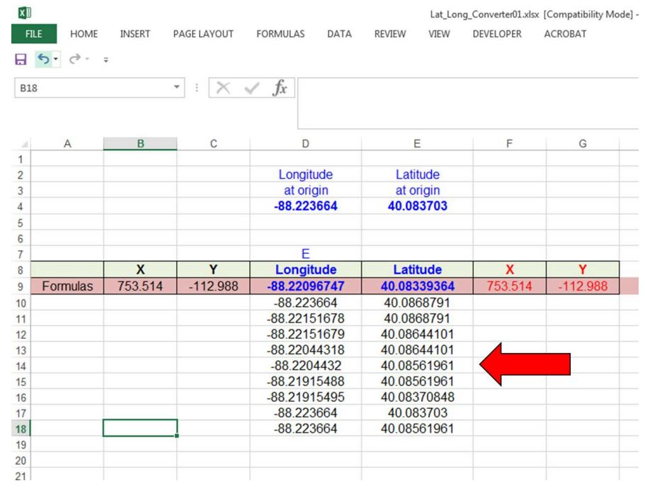
- Copy the formulas from the right X-Y columns into the rows with the boundary coordinates. The coordinates will be in feet, relative to the local origin. Watch the lab2 video for this step of the procedure at:
https://mediaspace.illinois.edu/media/t/1_xbrm1rcx
- Plot the XY boundary points to be sure that lines do not cross. Do NOT include the coordinates in the Formula row. Watch the lab2 video for this step of the procedure at: https://mediaspace.illinois.edu/media/t/1_xbrm1rcx
- Enter the X-Y coordinates for the boundary into the x and y columns at http://www.mathopenref.com/coordpolygonareacalc.html and calculate the area (sq. feet).
- Convert the result to acres and to hectares.

Deliverables:
Write your laboratory report following the lab_report_template. The report should include the following:
- Table of coordinates (from Excel)
- Plot of field (XY boundary from Excel)
- Area in ft² and acres

